CUSTOMER CHURN PREDICTION

EXECUTIVE SUMMARY

Background

Customer churn is a major challenge for banks of all sizes. According to a recent study by Bain & Company, the average cost of acquiring a new customer is five times the cost of retaining an existing one. This means that it is critical for banks to identify and address the factors that are leading to customer churn.

Customer churn impaired is the process of losing customers who are at high risk of churning. This can happen for a variety of reasons, such as dissatisfaction with the product or service, poor customer service, or competitive offerings. Customer churn impaired can have a significant impact on a company's bottom line, as it costs more to acquire a new customer than to retain an existing one.

There are several key trends and drivers of customer churn impaired. One trend is the rise of the digital economy. Customers have more choices than ever before, and they are more likely to switch to a competitor if they are not satisfied with their current provider. Another trend is the increasing importance of customer experience. Customers expect a personalized and seamless experience across all touchpoints. If a company fails to meet these expectations, customers are more likely to churn.

Understanding the key trends and drivers of customer churn impaired is essential for developing effective strategies to reduce churn. By identifying and addressing the factors that are driving customers away, companies can improve customer satisfaction and retention.

Problem statement
Customer churn is a major problem for our business. In the past year, our number of customers has decreased by around 30%, gross financing assets have decreased by 17% and cumulative profit payment slight decrease by 18% while our provisions slight has a decrease but maintain around the same from December 2020 until September 2023. This raises the concern that the bank’s customer becomes impaired. This will also result in a significant loss of revenue and profitability. We need to identify and address the root causes of customer churn to reduce the number of customers who are leaving our business.
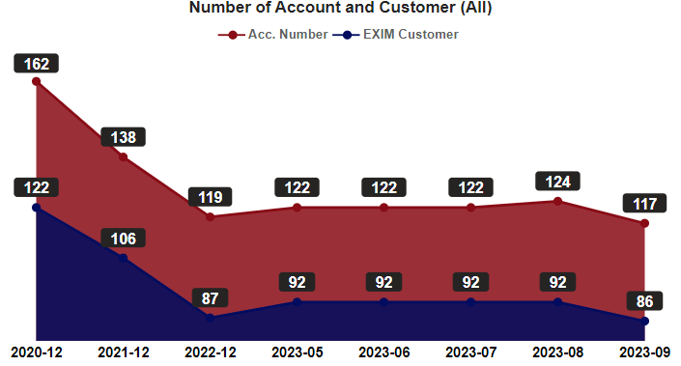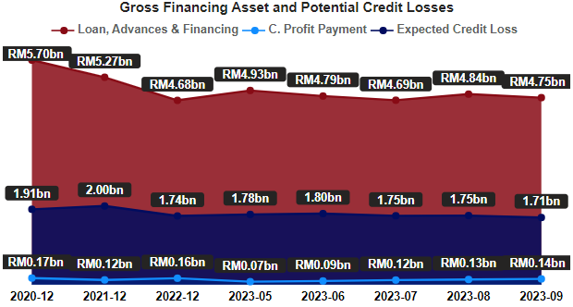
Figure 1.0
The figure above shows the movement of EXIM Bank losing customers with its cumulative profit faster than the bank can bring them on board (Refer Account Migration Section). Meanwhile, another concern to investigate is that the Gross Financing Asset is decreasing, but the provision amount at one point is increasing. It shows the quality of the existing customer is not good either.

Impact

Our Bank is significantly being impacted by customer attrition. Due to churn from December 2020 to September 2023, we have lost RM 0.95 billion in our gross financing asset and RM0.03 billion in cumulative profit payment throughout the year. Churn is a problem that will continue to harm the business if it’s not treated properly.

Detailed
Business Performance
EXIM Bank's primary line of business and profit is non-trade financing. Throughout the year, both trade and non-trade customers, as well as its financing asset's client base, are steadily diminishing while accrued profit and profit payments sluggishly increase throughout the year:
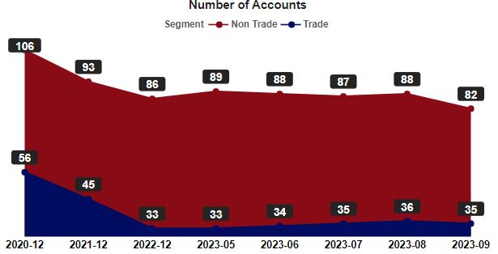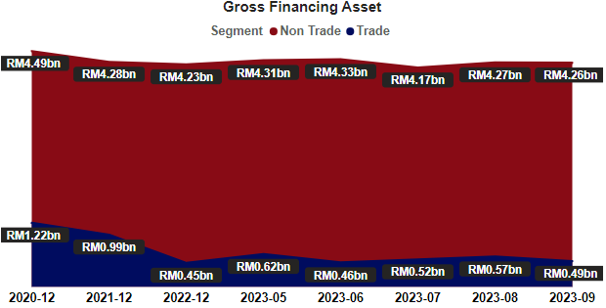
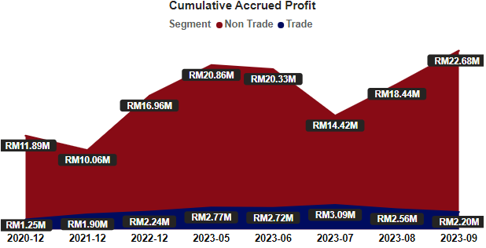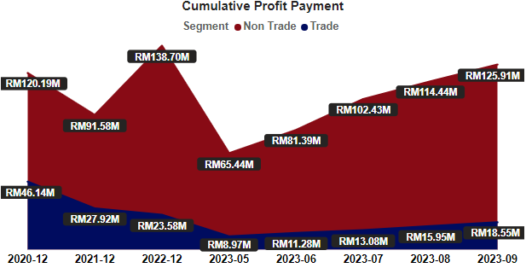
Figure 2.0
Customer Portfolio: September 2023
The chart below displays cumulative profit payment from EXIM clients as of the most recent position. Most profit generated are generally from non-trade, syndicated, and traditional markets, as well as term financing-i and overseas project financing facilities. With currencies of USD, Malaysia and Brazil generated the most profit from EXIM Bank customers. Aside from that, Active clients, non-SME entities in the and manufacturing and business industries as making profit as well.
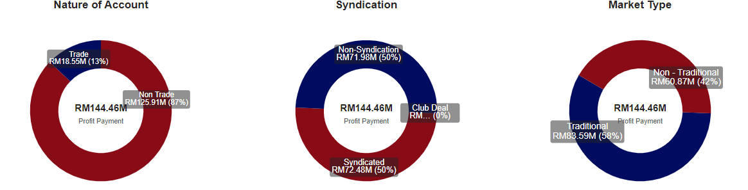
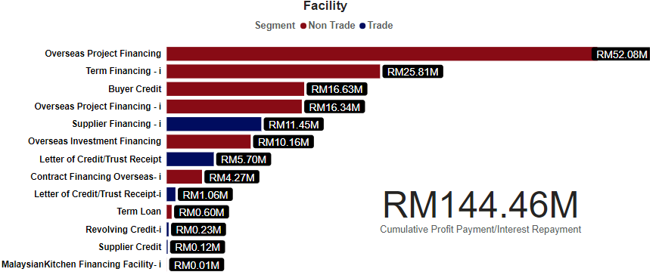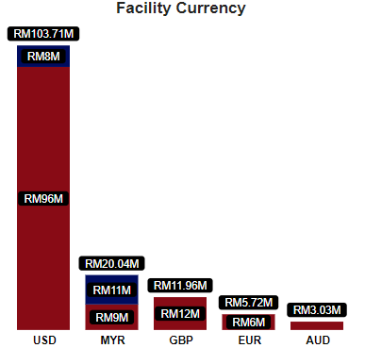
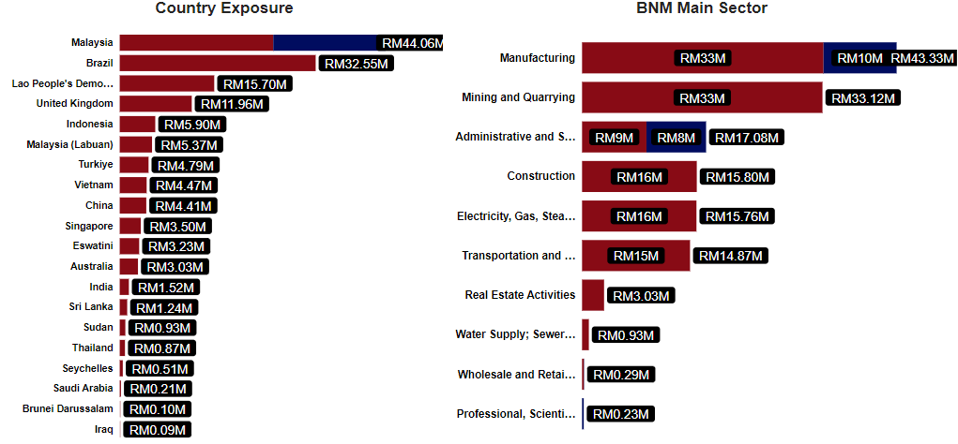
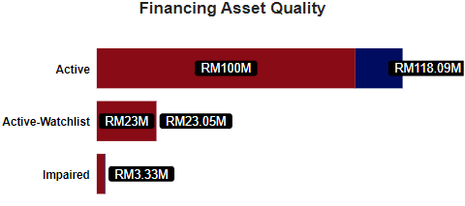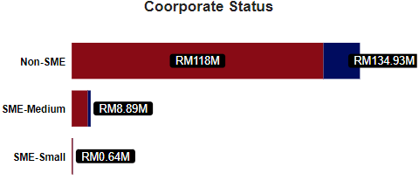
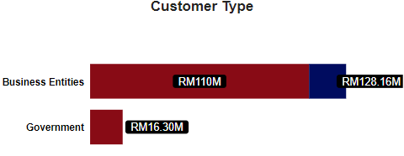
Figure 3.0
Customer Quality:
Even while the cumulative profit payment is decreasing, the financing asset quality movement appears to be better whereby more good customer during September 2023, though it is stable at the time being we should constantly be concerned since the number of our customers (122 to 86) and accounts (166 to 117) is declining, and most of them fall into the Impaired (high provisions) and Watchlist (medium provisions) categories throughout the course of these three years, as shown in Figure 4.0:
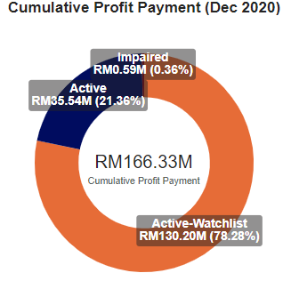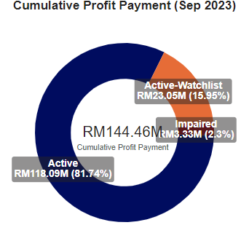
Figure 4.0
Since the decline of customers and accounts in the year 2021, the movement of EXIM Bank customers and accounts reveals a considerable increase for Active customers (37 – 46). As the number of accounts and customers rises, Watchlist and Impaired customer and account numbers eventually declines. There would be less money set aside by the Bank for the year 2023 compared to the year 2021 as a result of lower provisions or costs for Active customers and greater provisions or costs for Watchlist and Impaired customers. The chart below depicts the movement of accounts and customers who are Active, Watchlist, and Impaired:
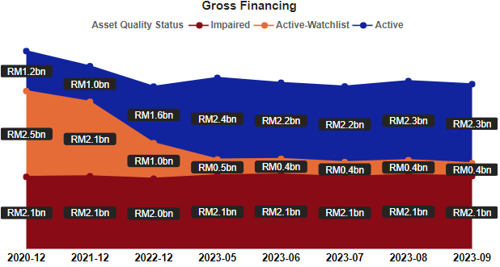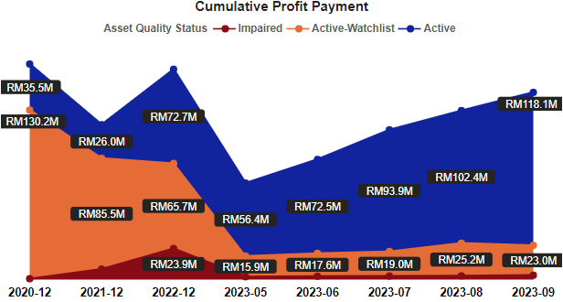
Figure 4.1
Impaired Trend
When the number of accounts for trade and non-trade declines but gross financing assets rise, the trend of impaired accounts becomes alarming. In addition, the Impairment Trend shows a peak from 2018 to 2019 before a sluggish increase in 2021 and 2022:
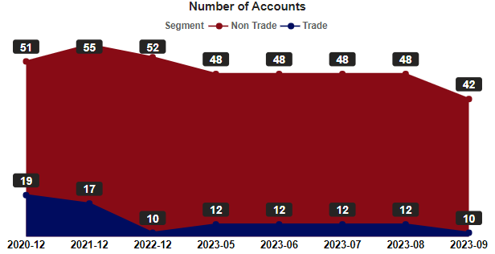 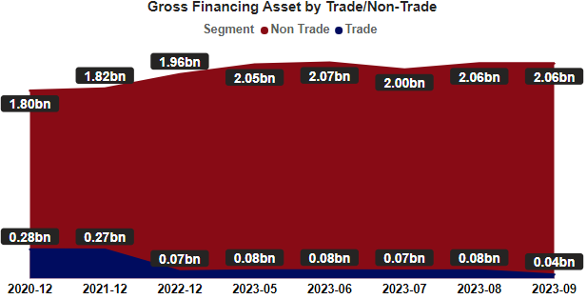 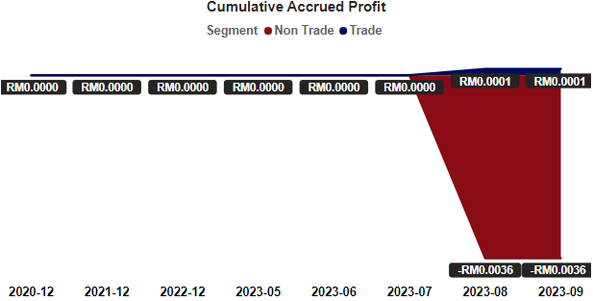Figure 4.2
Impaired Customer Portfolio: September 2023
Out of 52 number of impaired accounts, there are existing customer still in our book that impaired since 2008. Though we are probably losing our financing asset we are still making profit for some of the accounts as per shown in the figure below:
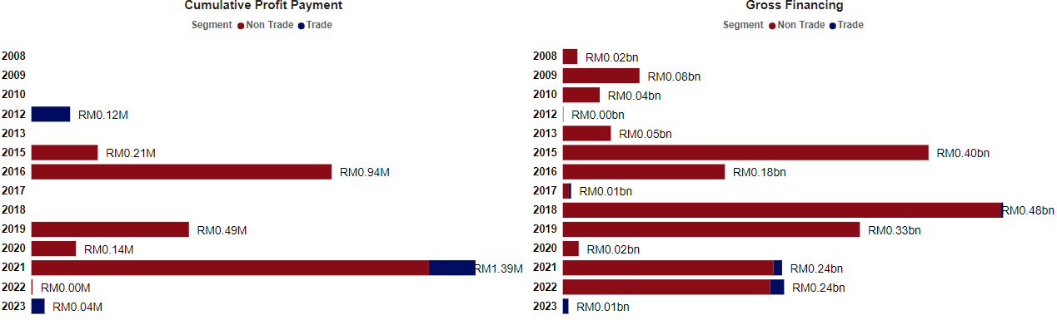
Figure 4.3
Most impaired accounts (18 accounts) are from non-trade financing, buyer credit and overseas project financing account consist of RM 1.30 billion (62%) of the impaired gross financing asset. The impaired account portfolio consists of non-MYR currencies and non-syndication/club deals with quarterly payment frequencies. According to the data, the two industries most affected by impairment are mining and transportation, and by country, Indonesia accumulates the longest period of impairment (2008, PT Eden Capital), the most accounts (16), and the highest amount of impairment (RM0.87 billion, 42%).
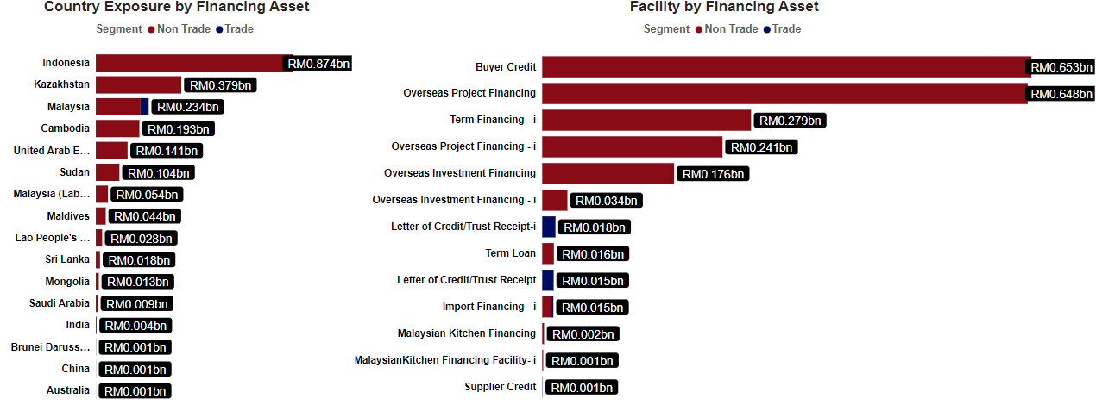
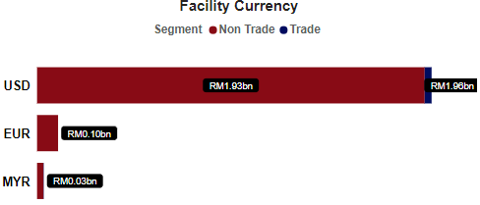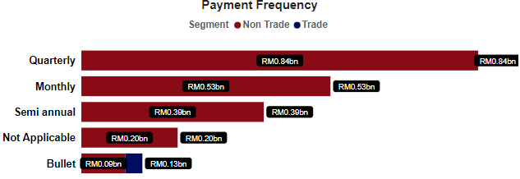
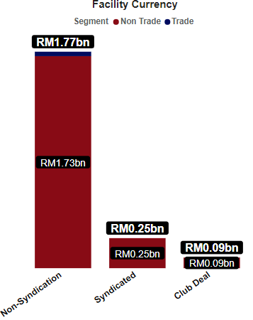 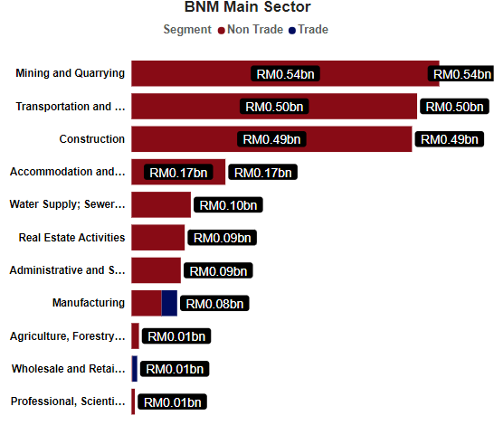 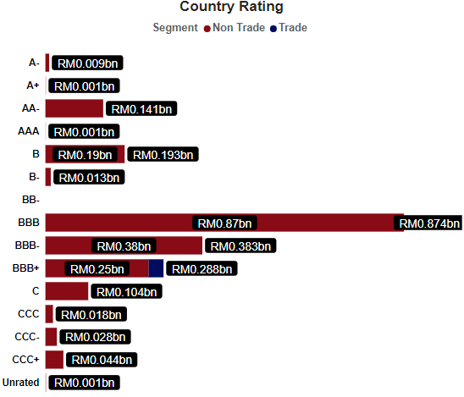 Figure 4.4
Behaviour Prediction
On a normal basis, the average for an account to turn impaired or watchlist is shown in figure 4.5. The interpretation of the figure can be translated by a one-way relationship, If the number of months increases the chances of turning watchlist or impaired decreases. The figures show watchlist has lowest number of months in 2021 while impaired has lowest number of months in 2020. In 2020, EXIM bank customers have a higher chance of becoming impaired after 15 months on board with EXIM, and those who are already impaired have a more difficult time turning watchlist by 46 months, probably due to the phenomenon of the COVID-19 uprising. Same goes for the watchlist. At the end stage of COVID-19, most companies are recovering, and Active customers have an easier chance to turn watchlist by serving 17 months with EXIM Bank but have a difficult time to turn impaired by serving 56 months. In a way, knowing how long it takes for customer churn is a good thing because then it can be monitored and followed up to prevent customer receiving negative experience.
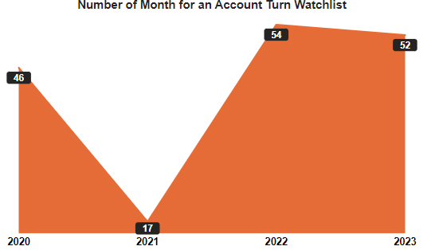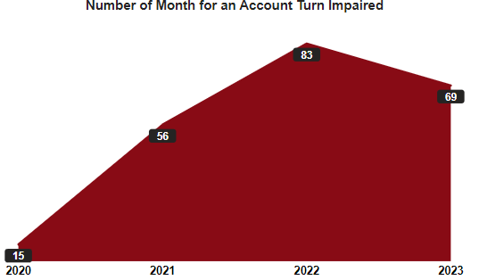
Figure 4.5
Accounts Migration
Table below shows number of accounts by asset quality segmentation throughout the year (Gross Financing and Cumulative Profit Payment can be refer in Figure 4.1):

Financial Asset Quality | Dec 2020 | Dec 2021 | Dec 2022 | Sep 2023
All Accounts | 162 | 138 | 119 | 117
Active | 37 | 17 | 26 | 46
Watchlist | 55 | 49 | 31 | 19
Impaired | 70 | 72 | 62 | 52
Table 1.0

Table below shows that the number of accounts & profit payment of the new account is slower than the dismissed accounts the number of accounts by migration segmentation (to validate, Ex. 2021 = 162 is (129 + 33) – 138 is (129 + 9) = 24):

All Account
Date | Dec 2020 | Dec 2021 | Dec 2022 | Sep 2023
Total | 162 Accounts | 138 Accounts | 119 Accounts | 117 Accounts
Account Movement | - | 24 Accounts | 19 Accounts | 2 Accounts
Gross Financing | RM5.70 billion | RM5.27 billion | RM4.68 billion | RM4.75 billion
C. Profit Payment | RM 0.17 billion | RM 0.12 billion | RM 0.16 billion | RM 0.14 billion
Maintain Accounts | - | 129 Accounts | 110 Accounts | 101 Accounts
Gross Financing | - | RM4.81 billion | RM4.32 billion | RM4.49 billion
C. Profit Payment | - | RM0.12 billion | RM0.15 billion | RM0.14 billion
New Accounts | - | 9 Accounts | 9 Accounts | 16 Accounts
Gross Financing | - | RM0.46 billion | RM0.37 billion | RM0.26 billion
C. Profit Payment | - | RM1.73 million | RM7.37 million | RM6.07 million
Dismissed Accounts | - | 33 Accounts | 28 Accounts | 18 Accounts
Gross Financing | - | RM0.437 billion | RM0.802 billion | RM0.249 billion
C. Profit Payment | - | RM13.89 million | RM15.79 million | RM13.47 million
Reason | - | 16 – Fully Settled  5 – Cancelled  5 – Conversion  4 – Expired  3 – Fully Write Off | 14 – Fully Settled  9 – Fully Write Off  5 – Cancelled | 8 – Fully Settled  8 – Fully Write-Off  1 – Cancelled  1 – Conversion
Table 1.1

From the table below, the number of impaired accounts is sluggishly recovering and lesser new account that impaired but most of the dismissed account in a concern when mostly the accounts in fully written off from EXIM book. (to validate, Ex. 2021 = 70 is (61 + 9) – 72 is (61 + 11) = 2):

Impaired
Date | Dec 2020 | Dec 2021 | Dec 2022 | Sep 2023
Total | 70 Accounts | 72 Accounts | 62 Accounts | 52 Accounts
Account Movement | - | 2 Accounts | 10 Accounts | 10 Accounts
Gross Financing | RM2.08 billion | RM2.10 billion | RM2.02 billion | RM2.10 billion
C. Profit Payment | RM0.59 million | RM7.99 million | RM23.92 million | RM3.33 million
Maintain Accounts | - | 61 Accounts | 55 Accounts | 50 Accounts
Gross Financing | - | RM4.81 billion | RM1.79 billion | RM2.09 billion
C. Profit Payment | - | RM117.77 million | RM18.46 million | RM3.29 million
New Accounts | - | 11 Accounts | 7 Accounts | 2 Accounts
Gross Financing | - | RM0.46 billion | RM0.23 billion | RM0.006 billion
C. Profit Payment | - | RM1.73 million | RM5.47 million | RM0.04 million
Dismissed Accounts | - | 9 Accounts | 17 Accounts | 12 Accounts
Gross Financing | - | RM0.12 billion | RM0.37 billion | RM0.06 billion
C. Profit Payment | - | RM0.40 million | RM0.22 million | RM0.84 million
Reason | - | 3 – Fully Write-Off  3 – Fully Settled  3 – Conversion | 9 – Fully Write-Off  6 – Fully Settled  2 – Watchlist | 8 – Fully Write-Off  3 – Watchlist  1 – Cancelled
Table 1.2

Churn Prediction
The prediction uses logistic regression model, one of supervised machine learning algorithm that is used to predict the probability of an outcome. The model can indicate whether an account will turn impaired or not by setting up the correct parameter to predict those accounts. Listed parameter as per below:
- Trade/Non-Trade Segmentation
- Traditional/Non-Traditional Trade Market
- Customer Payment Frequency
- Customer Corporate Status
- Country Region
- S&P/Moodys Country Rating
- Customer Main Sector
- Customer Facility
- Facility Currency
The model shows accuracy 81% for active account to turn impaired while 96% for watchlist account to turn impaired. The active model shows there will be a migration of 10 active accounts turns impaired and 10 impaired accounts turn active while the watchlist model indicates there will be a migration of 2 watchlist accounts turns impaired and 7 impaired accounts turn watchlist.
Matrix table:
Active  (80.77%) | Suc-Obs | Fail_Obs |  | Watchlist  (96.15%) | Suc-Obs | Fail_Obs
Suc-Pred | 42 | 10 |  | Suc-Pred | 50 | 7
Fail-Pred | 10 | 36 |  | Fail-Pred | 2 | 12

Table 1.3

The Receiver Operating Characteristic (ROC) curves illustrates the diagnostic ability to determine for an account to turn impaired or vice versa. Under the ROC curves the overall account performance based on the 9 parameters listed above, if the probability of impairment for an account is above 0.5 in figure below, we consider for the account as churn to impaired while below 0.5 says otherwise.
ROC Curve:
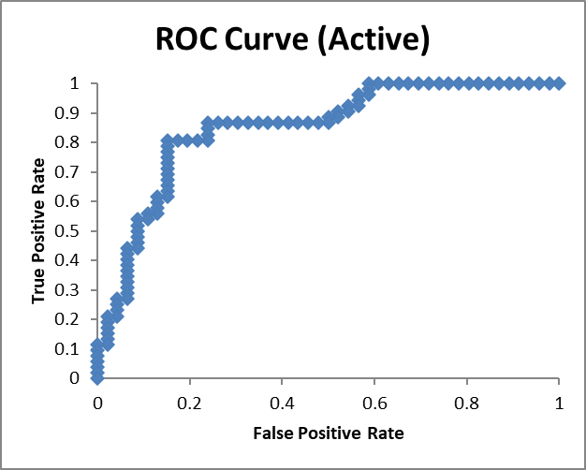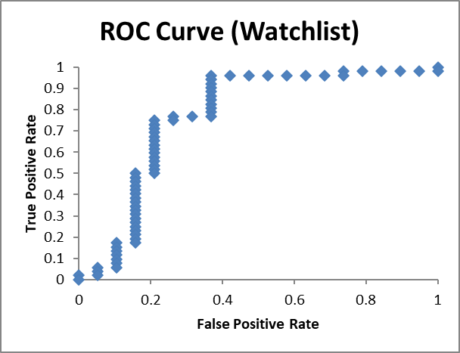
Figure 4.6
Notes: for Impaired Criteria Model 1 (Active) and Impaired Criteria Model 2 (Watchlist) please refer to appendix, figure 6.3 and figure 6.4 respectively.

Conclusion

The company has experienced a decrease in total customers, assets, and profits. Most assets and profits are now generated from non-trade activities. As of September 2023, 17% of the company's profits are still to be realized, with 8.8% from trade and 91.2% from non-trade activities. The company's most profitable criteria are those that are non-trade, syndicated, traditional, USD-based, overseas project financing, manufacturing, and non-SMEs in Malaysia where it contradicts with EXIM Bank mandate to provide emphasis on Trade and non-traditional markets.

There is a concern about impaired assets, as 50% of assets do not generate profit. Non-trade activities also contribute to most asset impairments. Indonesia has the most impaired accounts (16 accounts), with the longest impaired account dating back to 2008 (PT Eden Capital Indonesia). The largest impaired asset is also from Indonesia (PT Srivijaya Air).

For all exits accounts, most account are fully settled accounts, which is a good thing as the company does not have to carry losses. However, the company does carry losses for impaired accounts, as some exited accounts are fully written off.

Appendix
The following figure lists the top 15 customers in terms of largest loan:
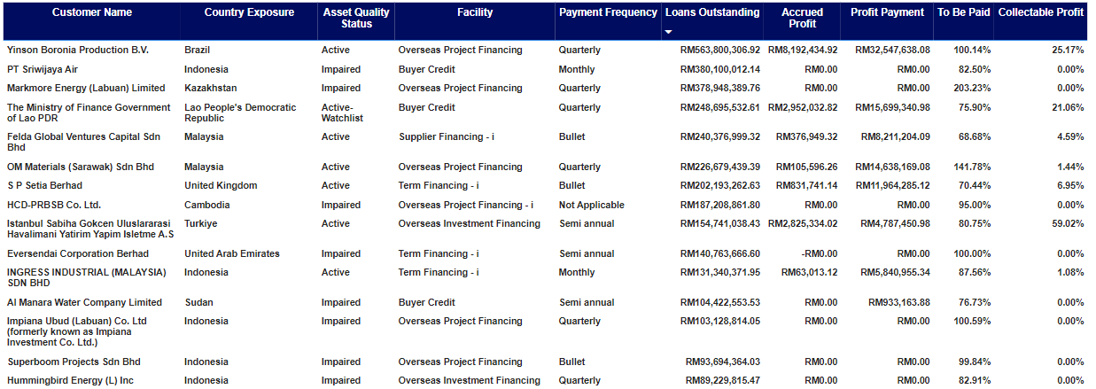
Figure 6.0

The following figure lists the top 15 impaired customers in terms of largest loan:
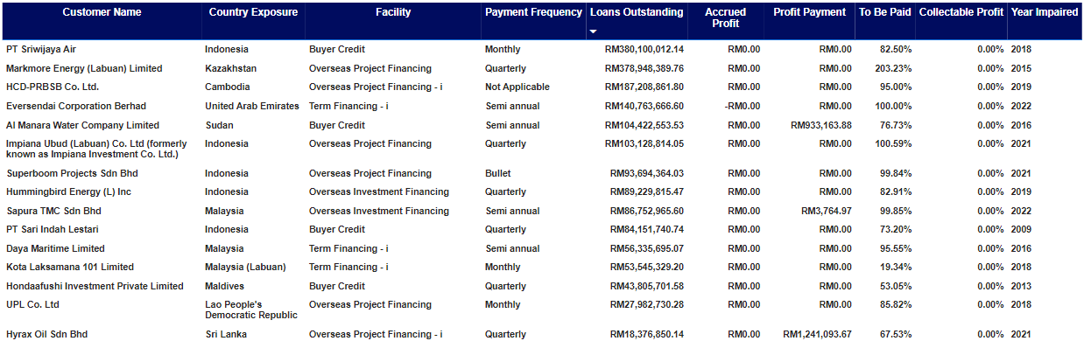Figure 6.1

The following figure lists the top 15 impaired customers in terms of longest impaired:
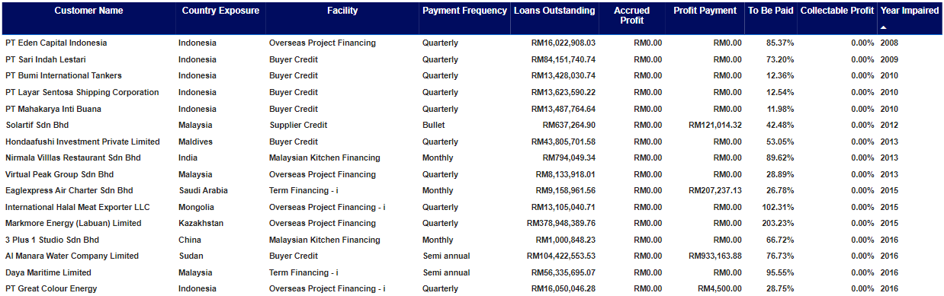Figure 6.2
The following table Shows the country rating by its region and country exposure:
Country Rating | Region | Country Exposure
A | Asia | Japan
A- | Middle East | Saudi Arabia
A+ | Asia | China
AA- | Asia | Chinese Taipei / Taiwan
AA- | Asia | Korea, Republic of (South)
AA- | Europe | United Kingdom
AA- | Middle East | United Arab Emirates
AA+ | Americas | Canada
AA+ | Americas | United States
AA+ | Oceania | New Zealand
AAA | Asia | Singapore
AAA | Europe | Germany
AAA | Oceania | Australia
B | Africa | Tanzania, United Republic of
B | Asia | Cambodia
B | Europe | Turkiye
B- | Africa | Eswatini
B- | Africa | Ghana
B- | Asia | Mongolia
B- | Europe | Bosnia and Herzegovina
BB- | Africa | Seychelles
BB- | Americas | Brazil
BB- | Asia | Bangladesh
BB- | Asia | Vietnam
BBB | Asia | Indonesia
BBB- | Asia | India
BBB- | Asia | Kazakhstan
BBB+ | Asia | Malaysia
BBB+ | Asia | Malaysia (Labuan)
BBB+ | Asia | Thailand
BBB+ | Europe | Spain
C | Africa | Sudan
CCC | Asia | Sri Lanka
CCC- | Asia | Lao People's Democratic Republic
CCC+ | Asia | Maldives
CCC+ | Middle East | Iraq
Unrated | Asia | Brunei Darussalam
Table 2.0

Impaired Criteria Model 1 (Active):

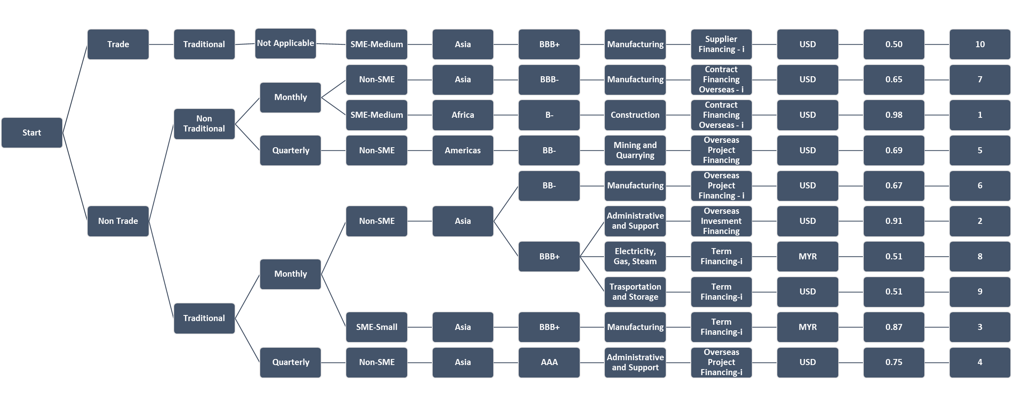
Figure 6.3
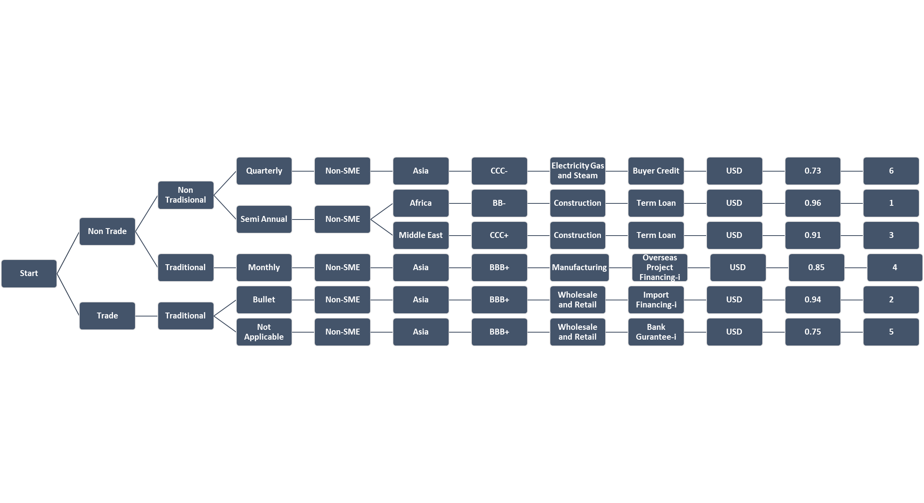
Impaired Criteria Model 2 (Watchlist):

Figure 6.4

